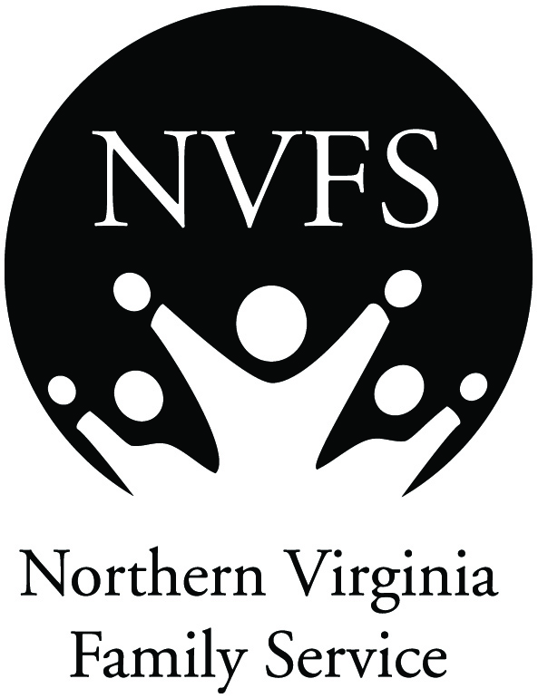
Health Marketplace
ACA Enrollment Counselor
Volunteer Position Description
For Open Enrollment: November 1, 2015 - January 31, 2016

Position: ACA Enrollment Counselor

Purpose: Affordable Care Act (ACA) Volunteer Enrollment Counselors are needed to help clients enroll in and understand their health coverage options, in English and other languages. Spanish, Arabic and Urdu speakers especially needed.

Duties:
- Volunteers assist clients in understanding their options in the Virginia Health Marketplace:
- Help clients set up an account and complete an application.
- Provide fair, accurate and impartial information to help clients make informed choices.
- Explain insurance coverage levels and how Premium Tax credits work.
- Help clients select a plan based on their individual needs and priorities.
- Adhere to NVFS privacy policies and document each individual meeting accordingly.

Qualifications:
- Ability to volunteer for at least four (4) enrollment sessions.
- Strong understanding of or willingness to learn about Health Marketplace eligibility and how to enroll.
- Competent navigating the Internet and using online application forms.
- Patience teaching others about complicated subjects with which they may have very limited knowledge.

Requirements:
- Successful completion of the online Certified Application Counselor training (approx. 5-7 hours).
- Complete and submit Volunteer Application paperwork and successfully complete NVFS background check.
- Attend mandatory NVFS orientation and training session.

Time Commitment: Minimum commitment of four (4) Saturday enrollment sessions during the Open Enrollment period from November 1, 2015 to January 31, 2016.

Benefits: Help people in your community enroll in health insurance and understand their benefits.

Support: Staff Program Coordinator is in ongoing contact with volunteers.
Materials and training offered in English and Spanish.

Training: Required online CAC training can be accessed at: https://portal.cms.gov
Once online training is successfully completed, email your Certificate of Completion to tgoplerud@nvfs.org. After attending the subsequent CAC orientation session at NVFS, you will be certified by NVFS as a CAC and can start volunteering! Ongoing support from NVFS includes various training opportunities.

Contact: Terry Goplerud, Volunteer Coordinator, Health Marketplace
tgoplerud@nvfs.org | 571.748.2582

