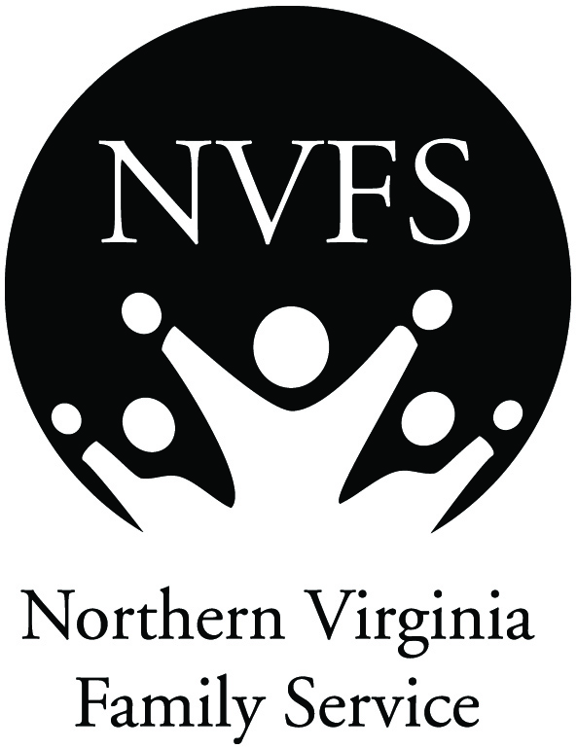
NVFS Multicultural Center Referral Form
6400 Arlington Blvd., Suite 110 • Falls Church, VA 22042 • 571.748.2800
Referring Agency: _____________________
Relationship to Client: _________________
Fax Number: _________________________
Parent/legal guardian must be aware of referral.
Has parent/legal guardian been informed of the referral?
Parent/Legal Guardian Name: __________
D.O.B.: __________________ Sex: ______
Address: ____________________________
City: ____________________ State: _____
County: ________________ Zip: _________
Country of Origin: _____________________
Contact Number: _____________________

Date of referral: _______________________
Person making referral: _________________
Contact Number: ______________________
If client is under 18: Complete parent/legal guardian section
Has client been informed of the referral?
Client’s Name: _______________________
D.O.B.: __________________ Sex: ______
Address: ____________________________
City: ____________________ State: _____
County: ________________ Zip: _________
Country of Origin: _____________________
Contact Number: _____________________
Language(s) spoken by client(s): __________________________________________________________
Current English ability: __________________________________________________________________

Language(s) spoken by parent/legal guardian: _______________________________________________
Current English ability: __________________________________________________________________

Time/Day available for services: ___________________________________________________________

Payment Method
 | Self-Pay
 | Insurance
 | Sliding Scale
 | Client would benefit from assistance with payment: |  |  |  | Yes | No
 | Notes:

Services Requested:
Counseling
Services for victims of domestic violence
Anger management
Substance abuse
Parenting classes
Program for Survivors of Torture and Trauma
Case Management
Immigration Legal Services
Housing Assistance
Other(s): _________________________________________________________________________

More information as needed

