De-escalation – 1 hour

What is de-escalation?
De-escalation refers to any activity that is meant to diffuse a conflict or intense situation. When foster children have blow-ups or outbursts, foster parents must respond in a way that diffuses the situation to ensure safety and calm the child.

What causes a child to escalate?
Brain imaging studies show that when an individual is under stress or reminded of a past traumatic event, there are physical (biological) changes in their brain. Under stress, the inner regions of a child’s brain becomes more active, and there is less blood flowing to the outer region of their brain. The outer region, also called the frontal cortex, is the area of the brain responsible for logical, rational thinking, planning and responding, and speech. The inner region of the brain are responsible for instinctive responses, such as emotion, respiration, arousal and the fight-flight-freeze response.

Many behaviors children display during a severe tantrum or meltdown are a result of the child’s inner (emotional) region of the brain being “turned up” and their outer (rational) region of the brain being “turned down.” This causes the child to have controlling, aggressive, destructive, hyperactive and unreasonable behavior. These behaviors are mostly or completely automatic depending on the child’s level of distress. The way in which foster parents respond to these behaviors either escalates or de-escalates (calming response) these behaviours.

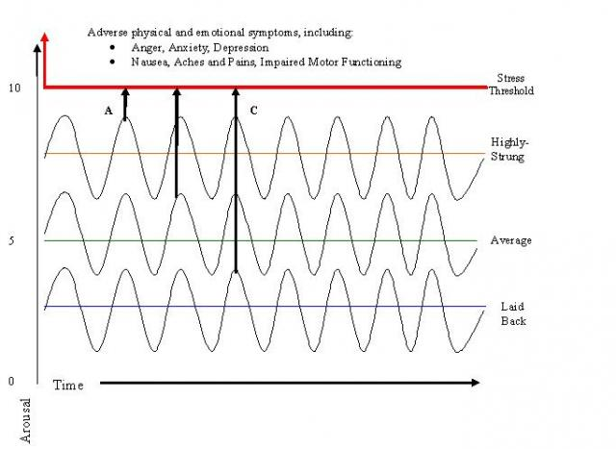
Severe tantrums, outbursts, and meltdowns occur when a stressor exceeds a child’s limit to cope. This limit is known as their “stress threshold”. Because of past trauma and abuse, many foster children can be categorized as “highly-strung” (see the diagram on the right). Since they operate at a higher arousal level, it takes very little stress to push them over their “stress threshold”.

Seven Phase Model of Acting Out Behavior
This diagram represents the level of intensity for the child’s behavior. Notice the child’s behavior starts as calm, then a trigger occurs, which upsets the child. The child is agitated and the behavior intensifies to the peak of the tantrum. After the peak, the child’s behavior settles down (de-escalates) and returns to a calm state.

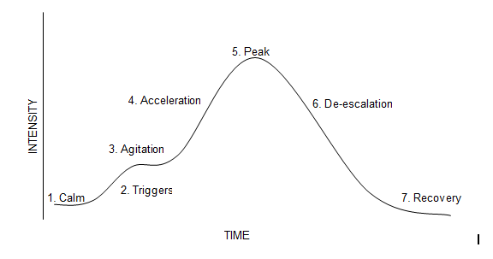

What are some possible triggers for foster children?
      - Speaking to birth family on phone
      - Being told ‘no’
      - A bad day at school
      - Requests from the foster parents to stop doing an enjoyable activity
      - Frustration from a learning disability
      - Fights over possessions or territory with siblings
- Anything that makes children feel vulnerable or treated unfairly

At this stage, foster parents should focus on reducing anxiety or redirecting attention in an effort to avoid a tantrum.

What are some warning signs during the agitation and acceleration phases?
Children may exhibit physical warning that foster parents can observe during the agitation and acceleration phases of the tantrum. These signs include clenched fist or teeth, a nervous twitch, rolling their eyes or glaring, and frowning. This stage is another opportunity for foster parents to focus on reducing anxiety or redirecting attention in an effort to avoid the peak of the tantrum.

What should foster parents do to de-escalate the tantrum?
- Focus on safety – remove children and others from the area, remove any objects that can be unsafe if thrown.
- Maintain calmness and speak in a soft, slow voice—we often mirror the voice and tone of those we speak to, so this will help the children lower their voice and help them calm down.
- Model emotional regulation—don’t appear angry or raise your voice. The child will feed off of your anger because he or she is looking for an emotional response from you. Appearing angry is like you giving the child permission to get angrier.
- Be prepared that they will keep trying to engage you—you may need to remove yourself from the child to get rid of the “audience”.
- Redirect the child with a new activity—try to distract the child with a pleasurable activity or toy.
- Don’t bargain or bribe a child during an outburst—children cannot use logic or reasoning skills during an outburst.
- Communicate one thought or idea at a time—children are not using rational thinking skills during an outburst, and you do not want to overwhelm the child with speaking in long sentences.
- Don’t discipline—by trying to discuss the tantrum or give consequences, you will only escalate the child’s tantrum.
- Try relaxation techniques—encourage the child to count to 10 before speaking or take deep breaths.

What are some pointers for foster parents?
- Identify what typically sets the child off. It's important to recognize patterns.
- Set up clear rules.
- Develop a safe, caring relationship.
- Communicate requests or directions to the child in ways that are the most calm and least provocative to the child.
- Recognize and reward even the smallest steps toward good behavior.
- Note what a child has said or how he has reacted emotionally and verbally to learn the child's point of view.
- Don't try to solve the problem for the child, but work with the child to solve the problem and build awareness of the outburst.
- Help the child interpret the behavior, possibly by drawing pictures and translating them into words.
- Reward with praise for initial, tentative steps in the right direction.
- Avoid "I told you so" remarks.
- Evaluate consequences to see if they make things better or worse.
- Debrief with the child during or after the consequences.
- Help the child generate options to getting angry in order to peacefully achieve what he needs or wants.

Answer the questions for the below scenarios and email them to gsnaider@nvfs.org to receive credit for this training.

Myla’s foster mother asked her to do her math homework earlier than usual because she had a home visit later that evening. Myla hates math because she has a learning disability, and math is especially hard for her. Myla was sitting at the table working on her homework when her foster brother accidentally bumped the table. Myla threw her books on the floor, cussed at her foster brother and began screaming.

- What were some triggers for Myla?

- What can the foster mother do at this point to de-escalate Myla’s behavior?

Skyler’s foster father asked him if he wanted to walk the dog with him one evening, but Skyler decided not to go on the walk. Skyler’s foster mom asked him to clean his room. He frowned and told her he was going to hide in the closet and surprise his foster dad when he returned from walking the dog. As the foster dad and dog came inside the house, the dog ran where Skyler was hiding. Skyler blew up at his foster mother.

- What were some triggers for Skyler?

- What can the foster parents do at this point to de-escalate Skyler behavior?

